RS-LDO-N01-2

Fluorescent dissolved oxygen transmitter

user 's manual
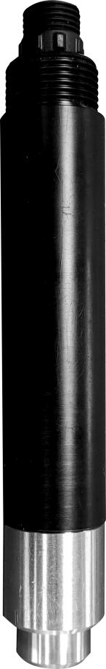

catalogue
1. Product introduction 3
1.1 Features 3
1.2 Equipment technical parameters 3
1.3 Product selection 3
1.4 inventory 4
1.5 Equipment size 4
1.6 equipment installation 4
2. Equipment instructions 5
2.1 Wiring instructions 5
2.2 Parameter configuration description 5
2.3Calibration instructions 6
2.3.1 Calibration preparation 6
2.3.2 calibration 6
2.4 ModBus Communication and register details 7
2.4.1Basic parameters of equipment communication 7
2.4.2Data frame format definition 7
2.4.3Register address 9
2.4.4Communication protocol example and explanation 10
3. Precautions and maintenance 11

1. Product introduction
This product is a device for measuring the concentration of dissolved oxygen in solution. It is based on the principle of fluorescence measurement. It does not consume oxygen and does not need electrolyte. Built-in temperature transmitter with automatic temperature compensation function. The calibration function provides a more simple and convenient calibration method. Fluorescent diaphragm with imported quality is adopted. It can be widely used in water treatment, aquaculture, environmental monitoring and other industries.

1.1 Features
1.Dissolved oxygen measurement range 0~20mg/L (0~200% saturation).
2.RS485 communication interface: MODBUS RTU communication protocol can be easily connected to the computer for monitoring and communication.
3.ModBus communication address can be set and baud rate can be modified.
4.The equipment adopts wide voltage power supply, DC 10~30V.
5.Fluorescent diaphragm with imported quality is adopted.
6.Fluorescence measurement principle is adopted, without oxygen consumption and electrolyte.

1.2 Equipment technical parameters
power supply | DC 10~30V
power waste | 0.2W
communication interface | RS485； Standard MODBUS-RTU protocol; Communication baud rate: 4800 by default (1200, 2400, 4800, 9600, 19200, 38400, 57600, 115200 can be set)
measuring principle | Fluorescence method
measuring range | 0~20mg/L（0~200% saturation）
measurement error | ±3%FS；±0.5℃（25℃）
resolving power | 0.01mg/L；0.1%；0.1℃
response time | ≤60sec
Equipment working conditions | 0~40℃
Fluorescent film life | Normal use 1 year
Waterproof grade | IP68
Withstand voltage | 0.6MPa
Electrode wire length | Default 5m
Shell material | Corrosion-resistant plastic, stainless steel

1.3 Product selection
RS- |  |  |  |  | Company code
 | LDO- |  |  |  | Fluorescent dissolved oxygen transmitter
 |  | N01- |  |  | RS485（Modbus-RTU agreement）
 |  |  | 2- |  | Integrated probe
 |  |  |  | 20 | 0~20.00 mg/L (0~200% saturation, 25 ℃)

1.4 product detailed list
◆1 fluorescence dissolved oxygen transmitter
◆5m cable
◆Certificate of conformity, warranty card, etc

1.5 Equipment size
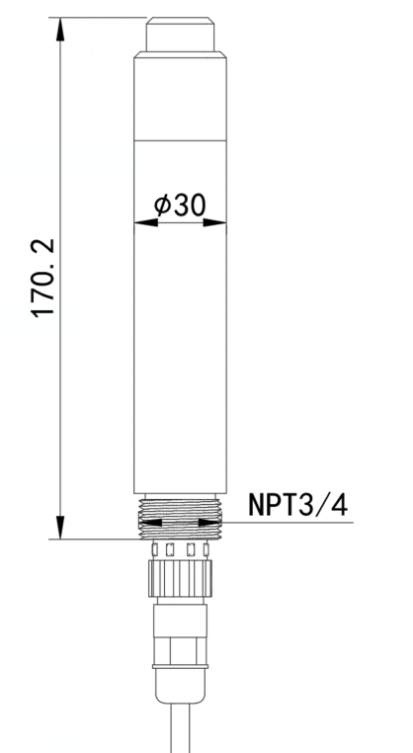

1.6 equipment installation
The sensor shall be immersed below the liquid level for fixed installation. During installation and use, avoid collision or scratch on the surface of the fluorescent film head. The fluorescent film head part shall be prevented from being attached by the sediment at the bottom of the water. The rubber protective sleeve shall be removed during use.

Submerged installation:

With NPT3/4 thread, it can be used with our waterproof pipe. Thread the cable out of the pipe and screw the equipment into the waterproof pipe thread.
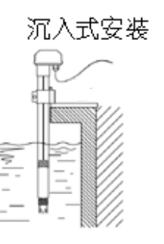

2. Equipment instructions

2.1 Wiring instructions

 | explain | explain
Power Supply | brown | V+（10~30V DC）
Power Supply | black | V-
communication | green | 485-A
communication | blue | 485-B

2.2 Parameter configuration description
Open the data package and select "Debugging software" - "485 parameter configuration software",findOpen it。
- Select the correct COM port (see the COM port in "My Computer - Properties - Device Manager - Port"). The following figure lists the driver names of several different 485 converters.
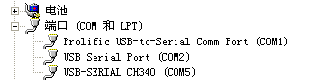
2) Connect and power on only one device separately, click the test baud rate of the software, and the software will test the baud rate and address of the current device. The default baud rate is 4800bit/s, and the default address is 0x01.

3) Modify the address and baud rate as required, and query the current function status of the device.

- If the test is not successful, please recheck the equipment wiring and 485 drive installation.
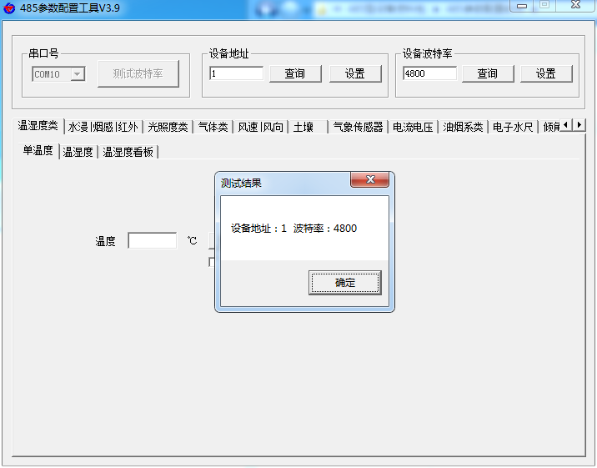

2.3Calibration instructions

2.3.1 Calibration preparation

Preparation of zero oxygen standard solution: in a place without wind and direct sunlight, take enough pure water (distilled water, deionized water) that has not passed through the stainless steel part of the equipment, add 5g anhydrous sodium sulfite per 95g of water, fully stir and dissolve to obtain 5% sodium sulfite solution, and leave it for 1 hour to ensure that the oxygen in the solution is completely consumed. If conditions permit, trace cobalt chloride can be added as catalyst.

Preparation for 100% oxygen environment: take enough pure water (distilled water, deionized water) that has not passed through the stainless steel part of the equipment in a place without wind and direct sunlight, use an air pump, continuously aerate the water with air for 1 hour, and then let it stand for 30 minutes to obtain air saturated water; Or in a place without wind or direct sunlight, use an airtight container, take a small amount of water, shake violently for 30s, get water saturated air, and keep the fluorescent film of the equipment about 1cm away from the water surface during calibration to ensure that the fluorescent film is wet but free of water droplets.

2.3.2 calibration
Find the dissolved oxygen tab in the water quality sensor tab in the configuration tool.
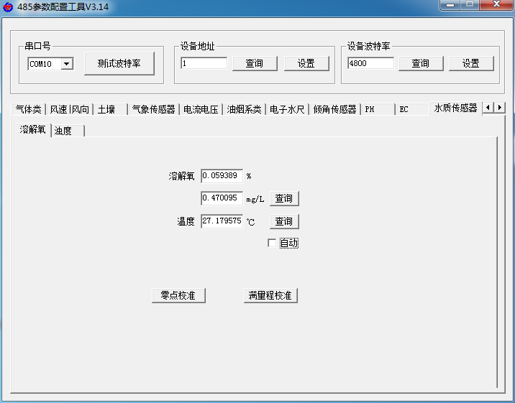
Place the sensor in a 100% oxygen environment. After the dissolved oxygen value is stable, click the full range calibration button to complete the calibration of 100% oxygen saturation.

Then put the sensor into the zero-oxygen standard solution, stir gently to accelerate the response, and then stand still. After the dissolved oxygen value is stable, click the zero-oxygen calibration button to complete the zero-oxygen calibration.

Note: The equipment shall be left standing for a long enough time in each calibration environment to ensure that the equipment temperature is the same as the ambient temperature.

2.4 ModBus Communication and register details

2.4.1Basic parameters of equipment communication
code | 8-bit binary
Data bits | 8 bits
Parity bit | -
Stop bit | 1 bits
Error check | CRC（Redundant cyclic code）
Baud rate | Factory default is 4800bit/s

2.4.2Data frame format definition
Modbus-RTU communication protocol is adopted, and the format is as follows:
Time of initial structure ≥ 4 bytes
Address code=1 byte
Function code=1 byte
Data area=N bytes
Error check=16-bit CRC code
Time to end structure ≥ 4 bytes
Address code: the address of the transmitter, which is unique in the communication network (factory default 0x01).
Function code: the instruction function indication sent by the host.
Data area: The data area is specific communication data. Note that the high byte of 16bits data comes first!
CRC code: two-byte check code.

2.4.3Register address
Register address | Support function code | explain
0x0000、0x0001 | 0x03/0x04 | Dissolved oxygen saturation (%; large end of floating point number)
0x0002、0x0003 | 0x03/0x04 | Dissolved oxygen concentration (mg/L; large end of floating point number)
0x0004、0x0005 | 0x03/0x04 | Temperature (℃; large end of floating point number)
0x1010 | 0x06/0x10 | Calibration (write 0x0001 calibration zero,  Write 0x0002 to calibrate 100% saturation point)
0x1020 | 0x03/0x04/0x06/0x10 | Salinity (‰; 16-bit unsigned integer, default 0)
0x1022 | 0x03/0x04/0x06/0x10 | Atmospheric pressure (kPa; default 101.33, 16-bit unsigned integer, actual value expanded by 100 times)
0x07D0 | 0x03/0x04/0x06/0x10 | 1~254 (16-bit unsigned integer, factory default 1)
0x07D1 | 0x03/0x04/0x06/0x10 | 0 for 2400  1 for 4800  2 for 9600  3 for 19200  4 for 38400  5 for 57600  6 for 115200  7 for 1200

2.4.4Communication protocol example and explanation
Example 1: Read the current dissolved oxygen saturation (%), dissolved oxygen concentration (mg/L) and temperature of the equipment with address 01
Send frame:
Address code | Function code | Register address | Register contents | Check code low bit | Check code high bit
0x01 | 0x03 | 0x00 0x00 | 0x00 0x06 | 0xc5 | 0xc8

Reply frame:
Address code | Function code | Number of valid bytes | Register contents | Check code low bit | Check code high bit
0x01 | 0x03 | 0x0c | 0x3f 0x6a 0xeb 0x52 0x40 0xe2 0x48 0xb0 0x41 0xe5 0x85 0xc5 | 0xa7 | 0x49
The big end of floating point number 3f 6a eb 52 is 0.917653, which means the dissolved oxygen saturation is 91.8%
Floating point number big end 40 e2 48 b0 is 7.071373 dissolved oxygen concentration is 7.07mg/L
The large end of floating point number 41 e5 85 c5 is 28.690317, indicating that the temperature is 28.7 ℃
Example 2: Write atmospheric pressure
Send frame: write atmospheric pressure 101.35kPa to the device with address code 1
Write 10135 to 0x1022 register and convert it to 2797 hexadecimal
Address code | Function code | Register address | Register contents | Check code low bit | Check code high bit
0x01 | 0x06 | 0x10 0x22 | 0x27 0x97 | 0x77 | 0x5e
Response frame: (according to MODBUS standard, the response is the image message of the next frame)
Address code | Function code | Register address | Register contents | Check code low bit | Check code high bit
0x01 | 0x06 | 0x10 0x22 | 0x27 0x97 | 0x77 | 0x5e
Example 3: Zero point calibration

The sensor writes 0x0001 to the 1010H register after the value is stable in oxygen-free water
Address code | Function code | Register address | Register contents | Check code low bit | Check code high bit
0x01 | 0x06 | 0x10 0x10 | 0x00 0x01 | 0x4d | 0x0f
Response frame: (according to MODBUS standard, the response is the image message of the next frame)
Address code | Function code | Register address | Register contents | Check code low bit | Check code high bit
0x01 | 0x06 | 0x10 0x10 | 0x00 0x01 | 0x4d | 0x0f

3. Precautions and maintenance
◆ In case of obvious failure of the equipment, please do not open it for self repair, and contact us as soon as possible!
◆ The fluorescent film at the front end of the equipment shall be free from collision or scratch. Any damage will lead to the reduction of measurement accuracy and even unavailability.
◆ Avoid using in organic solvents and cleaning fluorescent caps with organic solvents.
◆ When installing the equipment, try to avoid too tight or stressed cables.
◆ Equipment cleaning:
For the external surface of the equipment; It can be cleaned with tap water and wiped with a wet soft cloth. For some stubborn dirt, it can be cleaned with some household detergent in tap water;

For the outer surface of the fluorescent cap; Clean the dirt on the light window of the sensor with clean water; If it is necessary to wipe, use a soft cloth to gently wipe, do not scratch hard, to prevent damage to the fluorescent film, resulting in inaccurate measurement settings and unable to measure.

If there is dust or water vapor in the fluorescent cap: unscrew the fluorescent cap, wash the inner surface of the fluorescent cap and the optical glass window of the device with tap water. If there is greasy dirt, wash it with tap water mixed with household detergent, then wash the detergent, dry all cleaned surfaces with a lint-free soft cloth, and then put it in a dry place to completely evaporate the water.

It is recommended to clean it every 30 days.
◆ Remove the black rubber protective sleeve before measuring。
◆ During long-term storage, the sponge in the protective sleeve should be added with water and the excess water should be squeezed out to ensure that the fluorescent film is wet, and the temperature should be above 0 ℃ to prevent the fluorescent film from freezing and damage; If stored dry, the minimum temperature can reach - 10 ℃, and the equipment needs to soak in water for 48 hours to restore the response of the fluorescent film。
◆ It is recommended to replace the fluorescent film once a year.
◆ The equipment should be calibrated before each measurement. It is recommended to calibrate it every 3 months for long-term use. The calibration frequency should be adjusted appropriately according to different application conditions (the degree of dirt in the application, the deposition of chemical substances, etc.).

